Intro:

Menu :

Play Game :

Board:

Use Keyboard Keys (WASD) To Move Cursor And Use Enter To Swap.

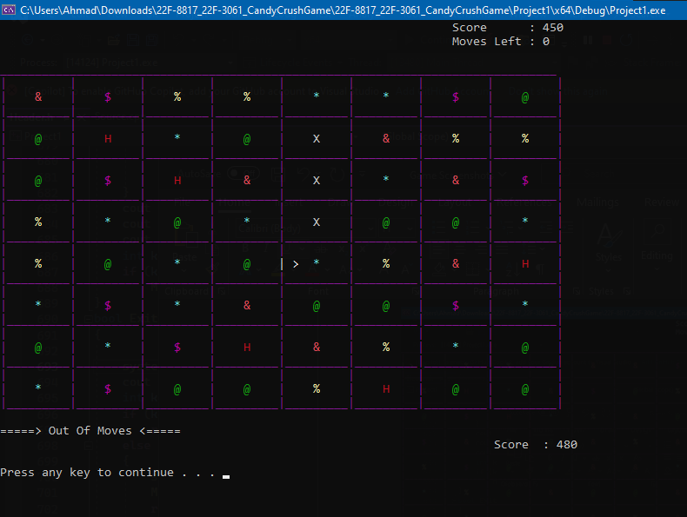

Highest Score:

Credits:

